YUKEN INDIA Ltd.
Summer Internship — PCB Design Project Report

Industrial Condition Monitoring Board
A purely Analog PCB Design

Intern | Avyukth M A
Programme | B.Tech ECE, VIT Chennai
Host Organisation | Yuken India Ltd., CSD Department
Design Tool | KiCad 10
Dates | May 25 – June 06, 2026

1. Abstract
This report documents the design and development of the Industrial Condition Monitoring Board, a printed circuit board (PCB) created as the culminating project of the Analog Electronics phase of the internship at Yuken India Ltd.

The board monitors three independent physical parameters — temperature, pressure and ambient light — using purely analog circuitry. All decision-making is performed without a microcontroller, demonstrating the application of operational amplifiers, comparators, and transistor-based logic to real-world industrial monitoring scenarios.

The design was completed in KiCad 10, progressing through schematic capture, PCB layout, design rule verification (DRC/ERC), and Gerber file generation. The board achieved 0 errors and 0 warnings on final verification.

The complete project, including design documentation, KiCad schematic files, PCB layouts, manufacturing outputs, and project reports, is available at the following GitHub repository: GitHub Repository Link.

2. Project Objectives
The project was designed to consolidate and demonstrate the following competencies developed during the Analog Electronics internship weeks:

- Apply operational amplifier theory — non-inverting amplifier gain configuration
- Implement comparator-based threshold detection for multi-level classification
- Design Schmitt trigger circuits with controlled hysteresis
- Perform signal conditioning — low-pass filtering, amplification, and reference generation
- Construct analog decision logic using discrete transistors (no digital ICs)
- Execute a complete PCB design workflow: schematic → layout → DRC → Gerber output
- Work with mixed-technology PCB — SMD passives/ICs and through-hole connectors/transistors
- Produce a manufacturable PCB with organised layout, clean routing, and a ground plane

3. System Overview
The board contains three independent monitoring channels, each processing a sensor input through signal conditioning and comparator logic to drive a set of colour-coded LED indicators. A common power supply section generates a regulated 5 V rail from a 12 V DC input.

Channel | Sensor | Indicators | Key Technique
Temperature | LM35 (external) | Green / Yellow / Red LEDs | Op-Amp amplification + dual comparators + transistor AND logic
Pressure | Potentiometer / analog signal (external) | Green / Yellow / Red LEDs | Resistor ladder references + dual comparators + transistor AND logic
Light | LDR (external) | Green / Red LEDs | Voltage divider + Schmitt trigger hysteresis

The design intentionally excludes microcontrollers, FPGAs, and digital logic ICs. All threshold decisions, zone detection, and output control are performed by analog components.

4. Power Supply Section

4.1 Input and Protection
The board accepts a 12 V DC input through a 2-pin terminal block (J1). A 1N5819 Schottky diode (D1) provides reverse polarity protection. The 1N5819 was selected for its low forward voltage drop (~0.3 V), minimizing power dissipation while protecting the downstream circuitry.

4.2 Voltage Regulation
An LM7805 linear voltage regulator produces a regulated 5 V output. Decoupling capacitors on both the input and output sides of the regulator ensure stability and ripple suppression:

Location | Capacitor | Purpose
Input side | 100 nF ceramic | High-frequency noise bypass
Input side | 10 µF electrolytic | Bulk decoupling, ripple reduction
Output side | 100 nF ceramic | High-frequency noise bypass
Output side | 10 µF electrolytic | Load transient response

A power indicator LED (D2) with a 680 Ω current-limiting resistor (R1) confirms 5 V rail presence. The LED operating current is approximately 4.4 mA.

5. Temperature Monitoring Channel

5.1 Sensor Interface
An external LM35 precision temperature sensor connects via a 3-pin terminal block (J2: +5 V, signal, GND). The LM35 produces a linear output of 10 mV/°C, requiring amplification to span a useful comparison range.

5.2 Amplifier Stage — U2A (LM358)
The first op-amp section (U2A) is configured as a non-inverting amplifier:

Parameter | Value | Notes
Configuration | Non-inverting amplifier | —
Feedback resistor Rf | 40 kΩ | R2
Input resistor Rin | 10 kΩ | R3
Gain Av | 5 V/V | Av = 1 + Rf/Rin = 1 + 40k/10k
Output at 40°C | 2 V | 40°C × 10 mV/°C × 5 = 2 V
Output at 60°C | 3 V | 60°C × 10 mV/°C × 5 = 3 V

5.3 Low-Pass Filter
A first-order RC low-pass filter (R = 10 kΩ, C = 1 µF) with a cutoff frequency of approximately 16 Hz is placed before the comparator inputs to suppress high-frequency noise from the sensor signal and power supply.

5.4 Threshold Detection — U3 (LM339)
Two comparator sections of the LM339 quad comparator IC (U3) implement dual-threshold detection:

Comparator | Reference Voltage | Temperature Equivalent | Output Net | Active When
U3A | 2 V | 40°C | TEMP_GT_40_N | Temperature > 40°C
U3B | 3 V | 60°C | TEMP_GT_60_N | Temperature > 60°C

5.5 LED Output Logic — Q1, Q2 (BC547)
Three zones are indicated with colour-coded LEDs. The green and red LEDs respond directly to the comparator outputs. The yellow LED (warning zone: 40–60°C) requires a logical AND of the two comparator outputs, implemented with two BC547 NPN transistors:

- Q1 (driver): switched ON by TEMP_GT_40_N — enables current path for yellow LED
- Q2 (inhibit): switched ON by TEMP_GT_60_N — pulls Q1 base LOW, disabling yellow LED

Condition | Green LED | Yellow LED | Red LED
T < 40°C | ON | OFF | OFF
40°C ≤ T < 60°C | OFF | ON | OFF
T ≥ 60°C | OFF | OFF | ON

6. Pressure Monitoring Channel

6.1 Sensor Interface
An external analog signal (0–5 V range) connects via J4, representing industrial pressure. A potentiometer is used for simulation and testing. No amplification is required since the input already spans the full 5 V reference range.

6.2 Signal Conditioning
A first-order RC low-pass filter (R = 10 kΩ, C = 1 µF) with a cutoff frequency of approximately 16 Hz smooths the input before it reaches the comparator network, preventing transient noise from causing false threshold crossings.

6.3 Reference Voltage Ladder
Three equal 10 kΩ resistors (R12, R13, R14) form a voltage divider across the 5 V rail, generating two reference points:

Reference | Voltage | Represents | Used By
Lower threshold | 1.67 V (5/3) | Lower third of pressure range | Comparator U3C
Upper threshold | 3.33 V (10/3) | Upper third of pressure range | Comparator U3D

6.4 LED Output Logic — Q3, Q4 (BC547)
Identical transistor logic to the temperature channel is used for yellow LED zone detection (1.67 V – 3.33 V), with Q3 as the driver and Q4 as the inhibit transistor.

Condition | Green LED | Yellow LED | Red LED
Signal < 1.67 V | ON | OFF | OFF
1.67 V ≤ Signal < 3.33 V | OFF | ON | OFF
Signal ≥ 3.33 V | OFF | OFF | ON

7. Light Monitoring Channel

7.1 Sensor Interface and Voltage Divider
An external LDR (Light Dependent Resistor) connects via J3. On the PCB, a 10 kΩ fixed resistor forms a voltage divider with the LDR between 5 V and GND. The mid-point voltage (LIGHT_SIGNAL) varies inversely with illumination — bright conditions produce a higher voltage, dark conditions a lower voltage.

7.2 Schmitt Trigger — U2B (LM358)
The second op-amp section (U2B) is configured as an inverting Schmitt trigger to provide hysteresis, preventing LED flicker at the switching threshold:

Parameter | Value | Notes
Reference voltage | 2.5 V | 10k/10k divider from 5 V rail
Positive feedback resistor | 100 kΩ | R20 — sets hysteresis band
Output net | LIGHT_CONDITION | HIGH = bright, LOW = dark

The positive feedback through the 100 kΩ resistor creates a hysteresis band around the 2.5 V reference, ensuring the output switches cleanly between states without oscillation near the threshold.

7.3 LED Output
- Green LED: illuminated when LIGHT_CONDITION is HIGH (bright environment)
- Red LED: illuminated when LIGHT_CONDITION is LOW (dark environment)

8. Bill of Materials — Key Components
Reference | Component | Value / Type | Package | Quantity | Function
U1 | LM7805 | 5 V regulator | TO-220 | 1 | Power regulation
U2 | LM358 | Dual op-amp | SOIC-8 | 1 | Amplifier + Schmitt trigger
U3 | LM339 | Quad comparator | SOIC-14 | 1 | All threshold detection
D1 | 1N5819 | Schottky diode | DO-41 | 1 | Reverse polarity protection
Q1–Q4 | BC547 | NPN transistor | TO-92 | 4 | Yellow LED AND logic
D2–D10 | LED | Various colours | 1206 SMD | 9 | Status indicators
R (various) | Resistor | 10k / 20k / 40k / 100k / 680Ω | 0805 SMD | 31 | Biasing, filtering, limiting
C1–C7 | Capacitor | 100nF / 1µF / 10µF | 0805 / 1206 | 7 | Decoupling, filtering
J1–J4 | Terminal block | Phoenix 5.08mm pitch | Through-hole | 4 | External connections

9. Schematic Design
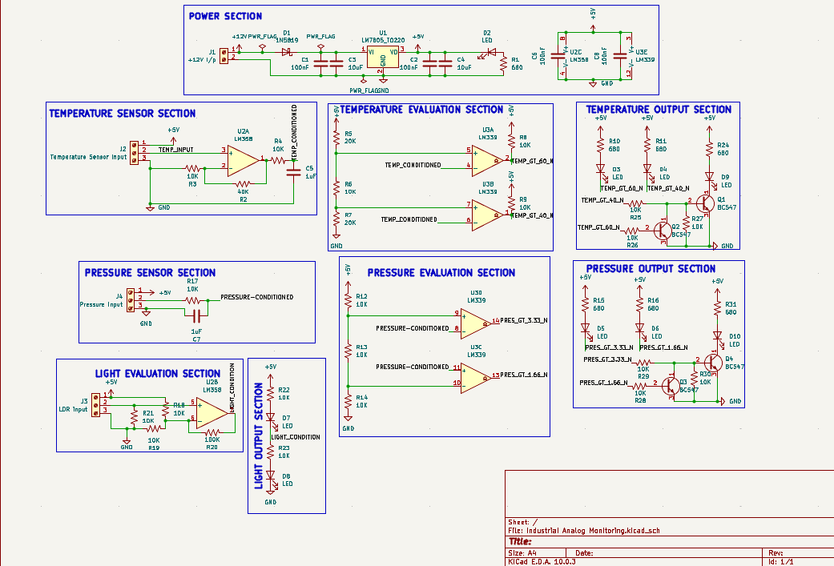

10. PCB Design Details

10.1 Layer Stack-up
Layer | Usage
Front Copper (F.Cu) | All signal routing, 5 V and 12 V power traces
Back Copper (B.Cu) | Solid ground plane — uninterrupted copper pour
Front Silkscreen | Component references, polarity markers, connector labels
Front/Back Solder Mask | Solder mask to prevent bridging

10.2 Trace Widths
Net Type | Trace Width | Rationale
Signal traces | 0.25 mm | Low current signal routing
5 V distribution | 0.5 mm | Multiple load currents
12 V input / regulator | 0.8 – 1.0 mm | Higher current carrying requirement

10.3 Component Placement
The board is organised into functional blocks for clarity and signal flow optimisation:
Board Region | Block
Top-left | Power supply — J1, D1, U1, decoupling capacitors, power LED
Upper-centre | Temperature channel — J2, U2A, U3A/B, Q1, Q2, LEDs
Upper-right | Light channel — J3 (bottom), U2B, light LEDs
Lower-centre | Pressure channel — J4, U3C/D, Q3, Q4, LEDs
Right edge | All LED indicators grouped for easy observation

10.4 Grounding Strategy
A solid copper ground plane on the bottom layer provides a low-impedance return path for all circuits, reduces noise coupling between channels, and simplifies routing by eliminating the need to route individual GND traces.

10.5 Design Verification
Check | Result
Electrical Rules Check (ERC) | 0 Errors, 0 Warnings
Design Rules Check (DRC) | 0 Errors, 0 Warnings
Gerber file generation | Complete — all 9 layers exported
Drill file | Generated (.drl format)

11. PCB Renders

11.1 3D Top View

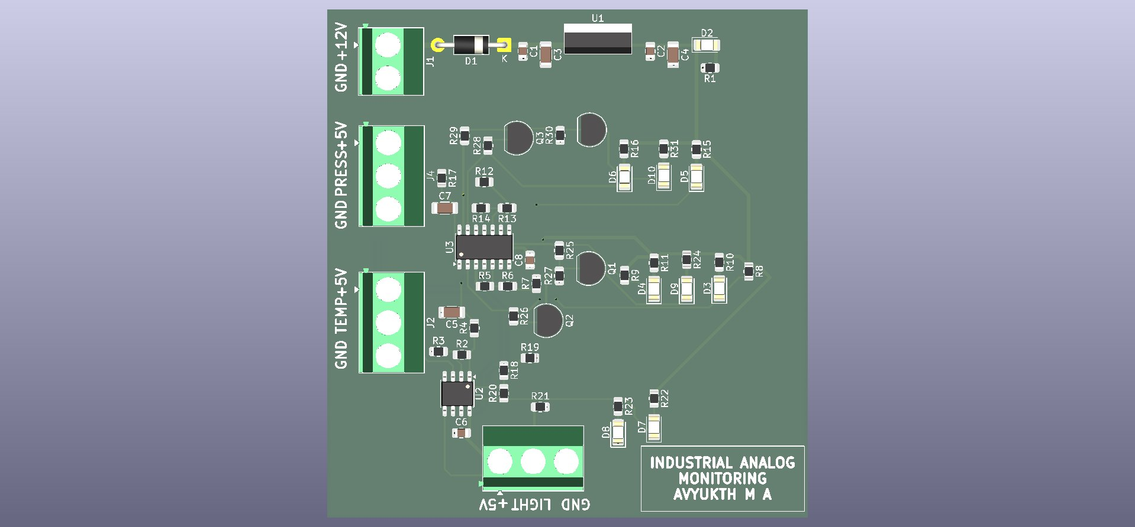
Figure 1 — Industrial Condition Monitoring Board (KiCad 3D Render, Top View)

11.2 PCB Layout (Top + Bottom Overlay)

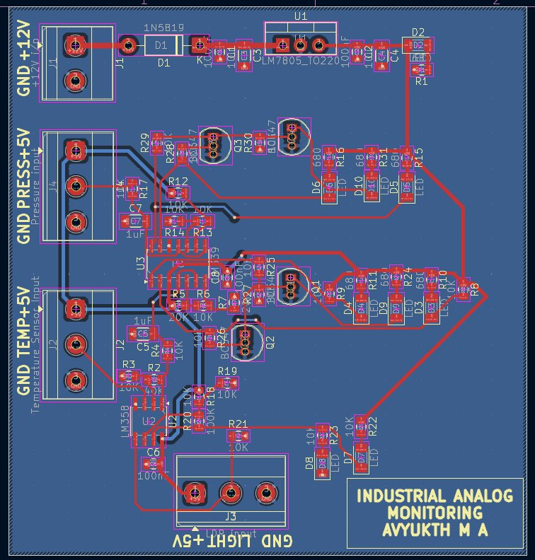
Figure 2 — PCB Layout showing front copper (red), back ground plane (blue), and silkscreen

12. Internship Learning Outcomes
This project served as a practical integration of the Analog Electronics topics covered during Weeks 1–2 of the internship. The following competencies were applied directly in the design:

Skill Area | Application in This Project
Op-amp gain design | Non-inverting amplifier (gain = 5) for LM35 signal conditioning
Comparator circuit design | Dual-threshold detection in temperature and pressure channels
Schmitt trigger / hysteresis | Light channel — noise-immune on/off switching with 100 kΩ feedback
Signal filtering | RC low-pass filters (10 kΩ / 1 µF) on all sensor inputs
Voltage reference generation | Resistor dividers for 2 V, 3 V, 1.67 V, 3.33 V, and 2.5 V references
Transistor switching logic | BC547 AND logic for zone-specific LED control
PCB design workflow | KiCad schematic → layout → DRC → Gerber — complete flow executed
Mixed-technology PCB | SMD components alongside through-hole connectors and transistors
Ground plane design | Solid B.Cu copper pour for noise reduction and clean return paths

13. Conclusion
The Industrial Condition Monitoring Board demonstrates that industrial-grade multi-parameter monitoring can be achieved entirely with analog circuitry — without a microcontroller. The design integrates operational amplifiers, comparators, transistor logic, and signal conditioning techniques into a single, cohesive PCB.

The project successfully passed all ERC and DRC checks in KiCad 10, and a complete Gerber file set has been generated, making the board ready for prototype manufacturing. The design serves as a practical demonstration of the Analog Electronics concepts covered during the Yuken India Ltd. internship and reflects a solid understanding of real-world circuit design practice.

Possible future enhancements to this design include:
- Adding a 4–20 mA current loop input stage for industrial sensor compatibility
- Integrating a buzzer driver for audible alerts at critical thresholds
- Designing a Rev B with adjustable threshold potentiometers on-board
- Extending the light channel to a multi-level LDR comparator arrangement

14. References
[1] Texas Instruments, "LM35 Precision Centigrade Temperature Sensors,"
Datasheet SNIS159H, Texas Instruments, Revised Aug. 2017.
[Online]. Available: https://www.ti.com/lit/ds/symlink/lm35.pdf

[2] Texas Instruments, "LM358, LM358A, LM2904, LM2904A Dual Operational
Amplifiers," Datasheet SNOSBT3, Texas Instruments.
[Online]. Available: https://www.ti.com/lit/ds/symlink/lm358.pdf

[3] Texas Instruments, "LM339, LM339A, LM2901 Family of Differential
Comparators," Datasheet SNOSC16, Texas Instruments.
[Online]. Available: https://www.ti.com/lit/ds/symlink/lm339.pdf

[4] onsemi, "MC7805CT, MC7805BT 1.0 A Positive Voltage Regulators,"
Datasheet, onsemi.
[Online]. Available: //www.onsemi.com/pdf/datasheet/mc7800-d.pdf

[5] onsemi, "BC546, BC547, BC548, BC549, BC550 General Purpose
Transistors,"Datasheet, onsemi.
[Online]. Available: https://www.onsemi.com/pdf/datasheet/bc546-d.pdf

[6] Diodes Incorporated, "1N5819 — 1.0 A Schottky Barrier Rectifier,"
Datasheet DS23001, Diodes Incorporated.
[Online]. Available: https://www.diodes.com/assets/Datasheets/ds23001.pdf

[7] KiCad EDA, "KiCad 10 Documentation," KiCad Project, 2024.
[Online]. Available: https://docs.kicad.org

